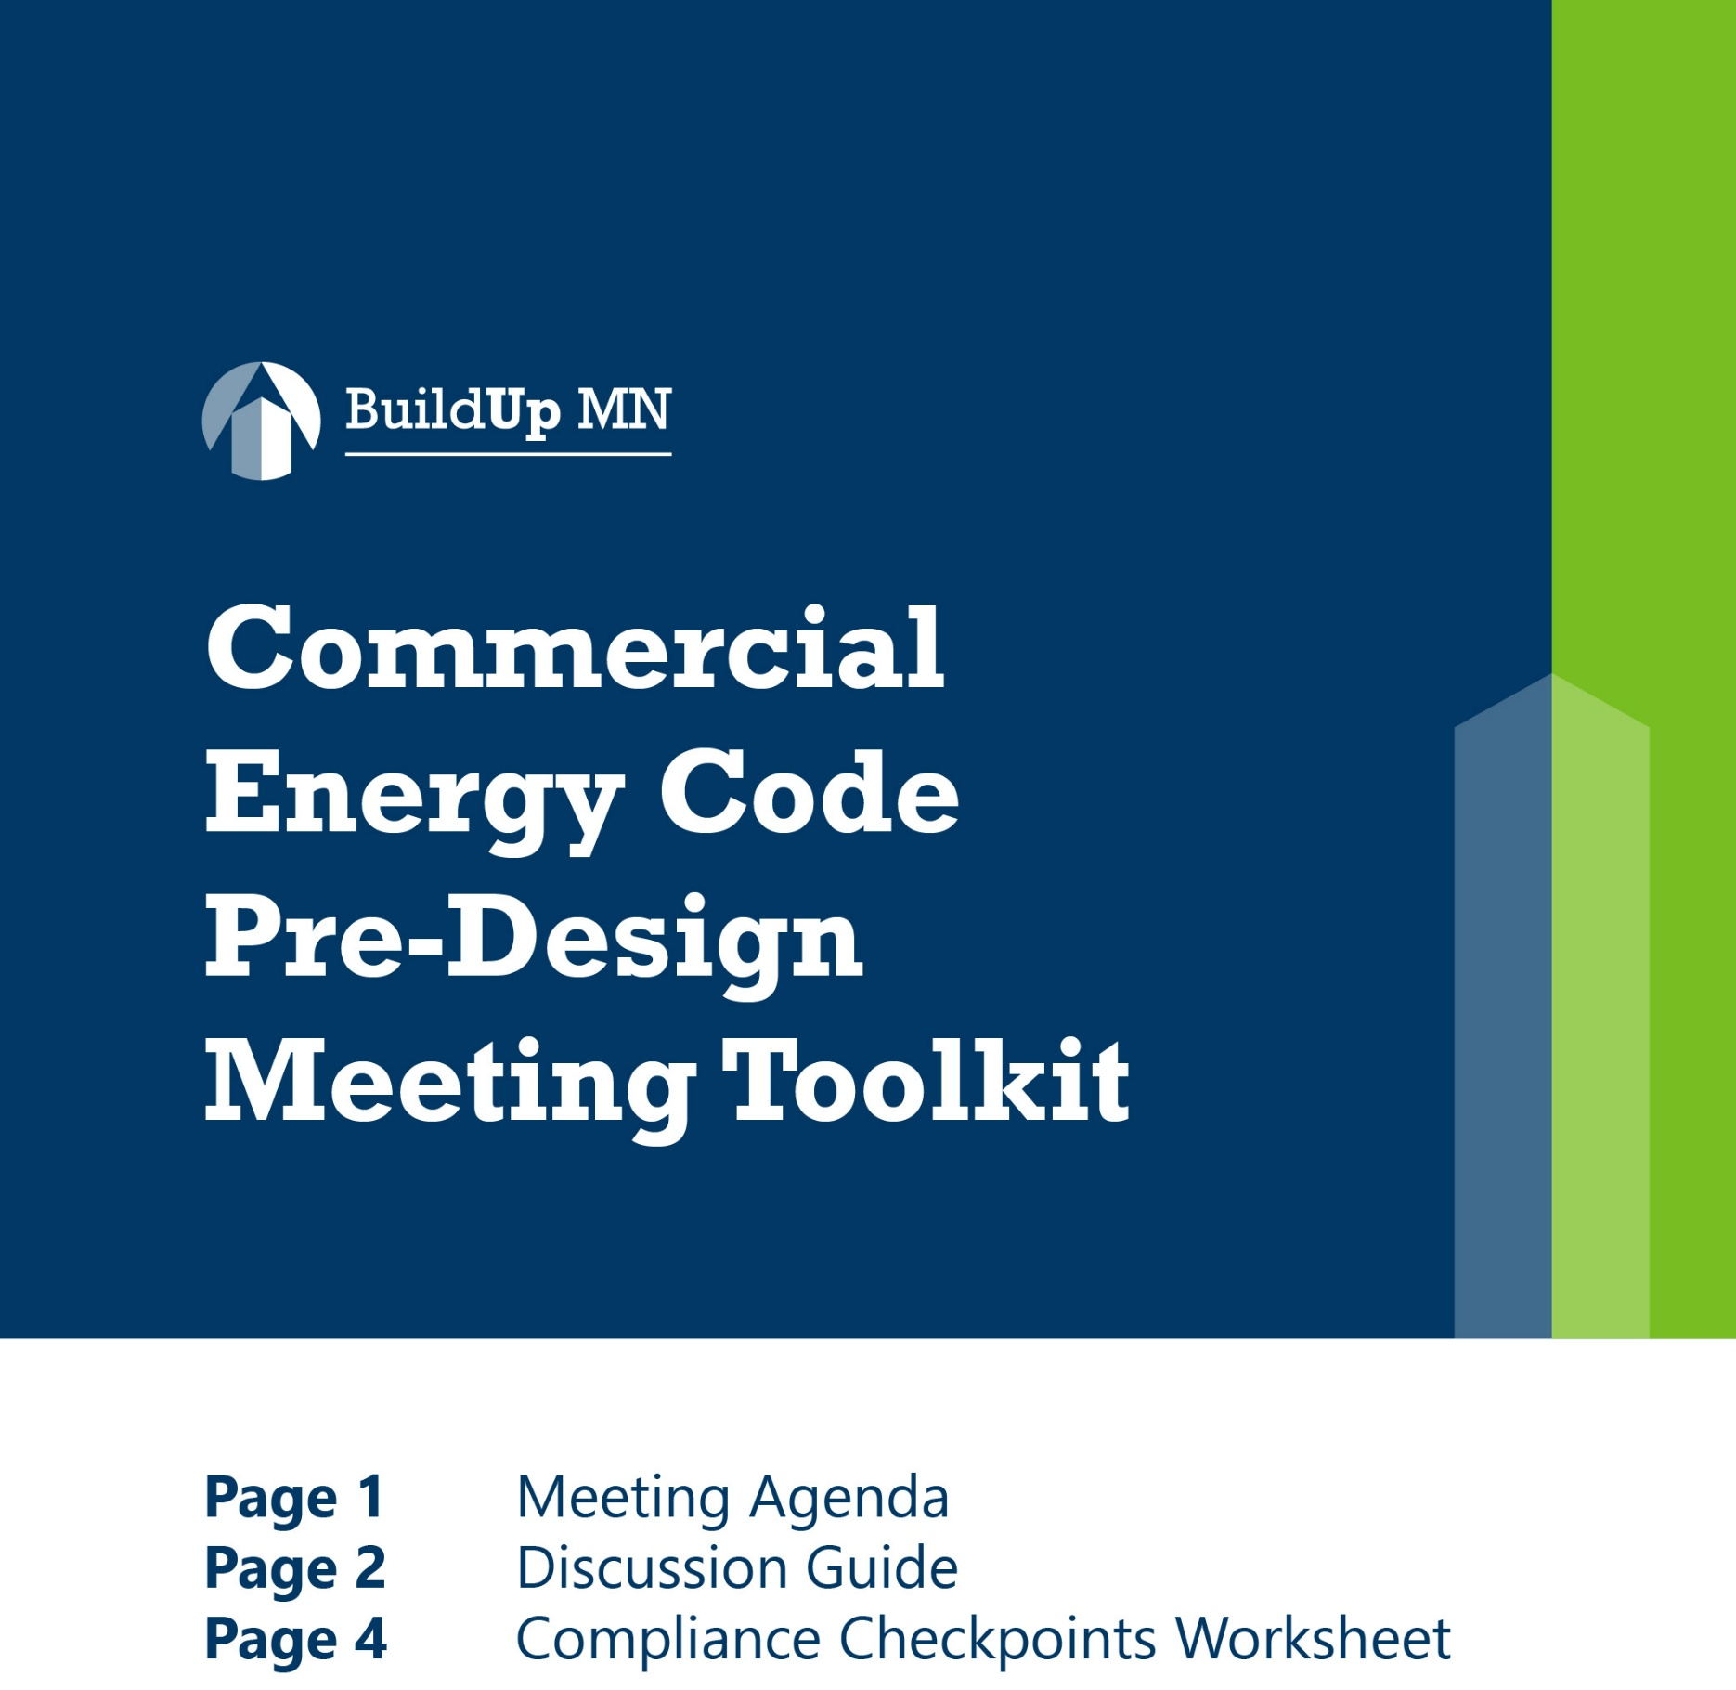

Visit BuildUpMN.org for additional resources.

Resource brought to you by BuildUpMN.org.

BuildUp MN is a statewide program through the Minnesota Advanced Energy Codes Partnership and Efficient Technology Accelerator. Minnesota's Efficient Technology Accelerator (ETA) is a partnership funded by the state’s participating investor-owned utilities (IOUs) and consumer-owned utilities (COUs), administered by the Minnesota Department of Commerce, Division of Energy Resources (DER), and implemented by Center for Energy and Environment (CEE).
The meeting agenda and discussion guide are intended to be integrated into an existing pre-design meeting to ensure energy code compliance considerations are addressed early in the design process. This resource is editable and intended to be customized to reflect the specific needs, scope, and delivery approach of your project.

Meeting Agenda

Meeting Objective
Establish an early strategy for energy code compliance by aligning the project team on compliance pathways, technical considerations, responsibilities, and future milestones. Early coordination helps save time and minimize costs by reducing permitting delays, redesign efforts, change orders, and construction-phase compliance issues.

Meeting Topics Overview
- Compliance Pathway (suggested timing: 10 minutes)

Goal: Establish the project's overall approach to energy code compliance before major design decisions are made.

- Technical Considerations (suggested timing: 30 minutes)

Goal: Identify energy code-related technical challenges early in the design process to maximize cost-effectiveness, allowing teams to proactively adapt design, budget, scheduling, and coordination.

- Roles and Responsibilities (suggested timing: 10 minutes)

Goal: Assign ownership so compliance tasks do not fall through the cracks.

- Future Milestones & Next Steps (suggested timing: 10 minutes)

Goal: Establish future energy code review points before permitting and construction.

Discussion Guide

1) Compliance Pathway

Need Support? See Energy Code Pathways Graphic for guidance.
- Has the compliance pathway already been decided? Which compliance pathway is proposed for this project?
- Is energy modeling required? If so, when will the modeling team be engaged?
- Are there any building envelope, mechanical, or lighting implications that should be considered regarding the compliance pathway?
- Are there owner requirements, certifications, funding requirements, or utility incentives that will overlap with or affect energy code compliance?

2) Technical Considerations

Need Additional Support? See BuildUp MN’s Quick Reference Guide for a summary of high-impact, commonly missed mandatory and prescriptive energy code requirements, including code section references.

Building Envelope
Building Envelope Design:
- Window orientation, window area, unique envelope conditions

Mandatory Requirements:
Air Leakage Testing
- What method is being used for meeting air leakage requirements (testing or continuous air barrier verification)?
  - Who will perform testing?
  - For projects pursuing continuous air barrier verification, when will design review occur?

Envelope Trade-off:
- For projects following the Building Envelope Trade-off compliance path, complete the COMcheck report early in the design process and include it with the appropriate design documents and specifications. Use the report to identify and track energy code requirements as the design develops.

Mechanical & Ventilation
HVAC System Design:
- Based on the selected or potential systems, what mandatory or prescriptive requirements will apply?
  - Who will be responsible for specifying mechanical control sequences and when will this be completed?
  - Will fan power calculations be required?

Mandatory Requirements:
Verification, Testing, and Commissioning
  - Who will perform testing?
  - When will the commissioning provider be engaged?
- Review of commissioning process and required deliverables (Section 4.2.5.2.2 Project Commissioning Documents)
  - Commissioning Plan, Design Review Report, Preliminary Commissioning Report, Final Commissioning Report

Other Discussion Topics:
- Early architectural/mechanical coordination needs

Lighting & Controls
Lighting system design:
- Lighting control strategy
  - Owner standards or operational requirements that impact the lighting control approach
- Spaces with specialized control needs
- Lighting power density

Mandatory Requirements:
Verification, Testing, and Commissioning
  - Who will perform testing?
  - When will the commissioning provider be engaged?
- Review of commissioning process and required deliverables (Section 4.2.5.2.2 Project Commissioning Documents)
  - Commissioning Plan, Design Review Report, Preliminary Commissioning Report, Final Commissioning Report

Other Discussion Topics:
- Early architectural/lighting programmatic coordination needs

3) Roles and Responsibilities
- Who will serve as the primary energy code compliance coordinator?
Identify the primary coordination lead responsible for facilitating communication and coordinating energy code-related decisions.
- Who will ensure energy code requirements are accurately reflected in the project drawings and specifications throughout design?
Identify the individual responsible for incorporating energy code requirements into the construction documents and verifying they are maintained through design revisions and value engineering.
- Are any key project team members missing?
- When will additional parties (GC, subcontractors, commissioning agent, energy modeler) be brought on?

4) Future Milestones and Checkpoints
At each milestone, confirm:
- Has the compliance strategy changed?
- Have any design changes affected compliance?
- Have value engineering decisions impacted energy code compliance?
- Are testing, inspections, and commissioning still on schedule?
- Have documentation responsibilities changed?

Key Energy Code Compliance Checkpoints
Milestone | Target Date | Owner | Notes
Planning & Design
Compliance pathway confirmed
Draft of envelope COMcheck report |  |  | Where applicable
Energy model initiated |  |  | Where applicable
Commissioning plan
Schematic design review
Air barrier design review |  |  | Where applicable
Commissioning design review report
Design development review
Permitting
90% construction documents review
Bid package review
Pre-permit compliance review
Final construction documents
Construction
Construction kick-off
Inspection, testing & verification planning
Preliminary commissioning report
Value engineering review
Final commissioning report

